A1 – E-R Modeling

  - Due: Monday, February 2, 2026
  - COMP 2521 – 001, Shoba Ittyipe
  - Authors: Vilav P, Lorenzo M.

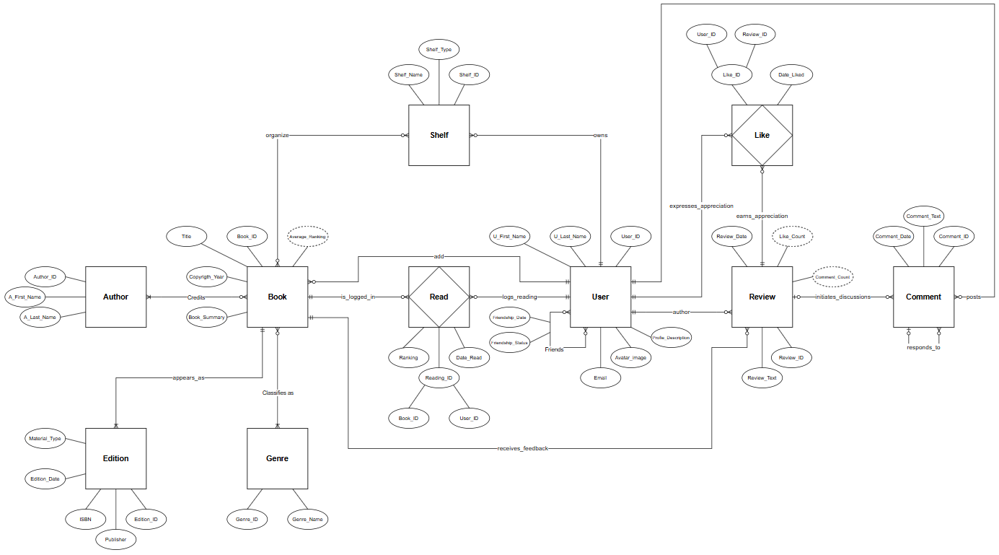

Assumptions:
- Users can only add book if book is not in BookClub database
- The authors in the BookClub database may have not written any books
- A user can have multiple shelves
- Each book can be stored in multiple shelves, ie. a book can be both non-fiction and computers
- User can be friends only if Friendship_Status == True for both users
- Users can only search other shelves if Friendship_Status == True between both users
- Each user can only log book as read once
- Each review and its user-author is associated with exactly one book
- A user many review a book at most once
- Comments may optionally reference another comment, allowing hierarchical discussion threads to be reconstructed.
- Aggregate values such as ‘Average_Ranking’, ‘Like_Count’, and 'Comment_Count’ are derived attributes that are not stored.
- Books have summaries attached to them

